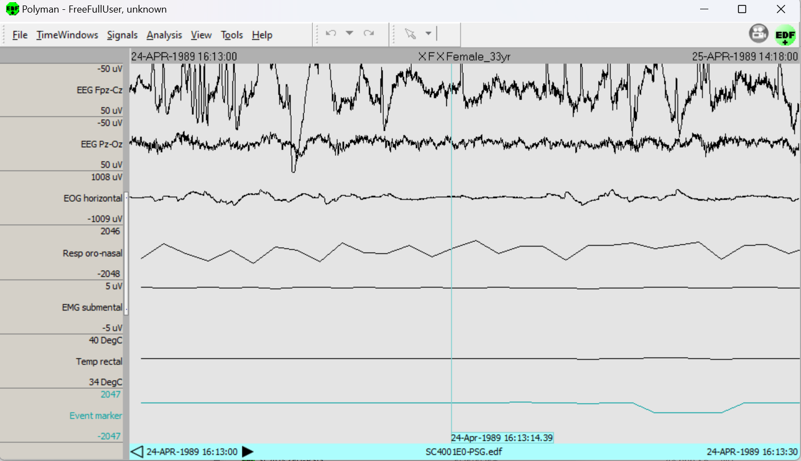**4.3 Results Obtained**

**Figure 4.2: Hypnogram**

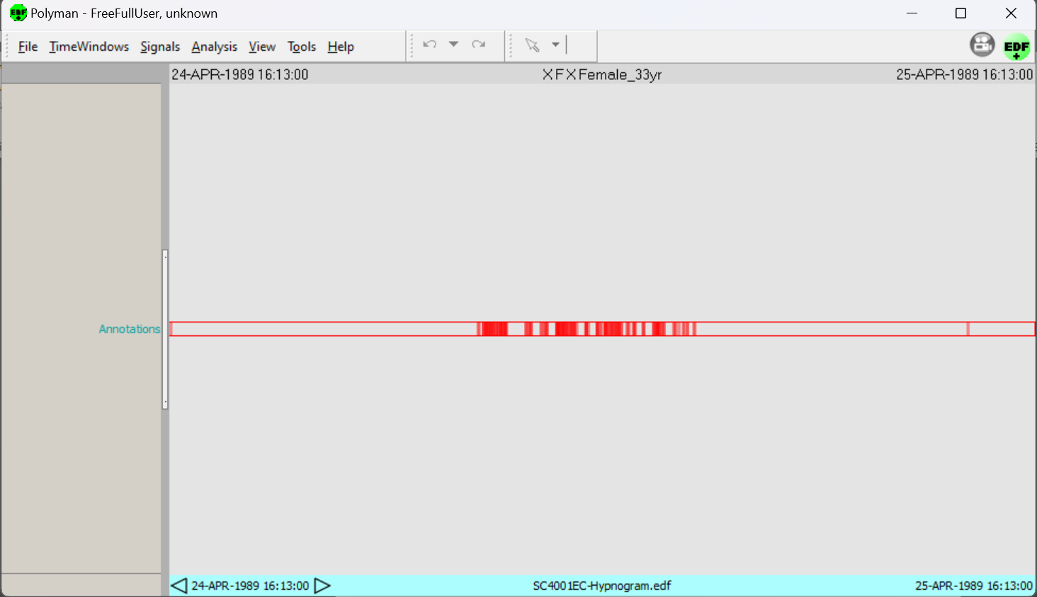

**Figure 4.3: PSG**